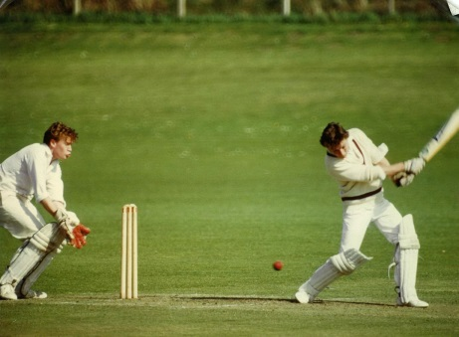
Game of Cricket
Rules and equipment of the game:
- How many players are there per team?
- What are the two objectives of the batter?
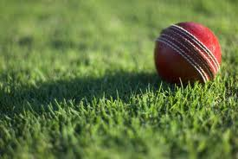
- How does the batter score one run?
- What is the difference between a 4 point hit and a six point hit?
- How many innings are in each game?
- When does an inning end?
- What is the typical equipment used by a batter?
- How many batsmen are required on the field at a time?
- How is the batsman out?
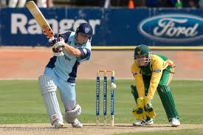
Terminology:
- What does it mean to be bowled?
- What is the pitch?
- What is an LBW or Leg-Before-Wicket?
- What is a hat trick in cricket?
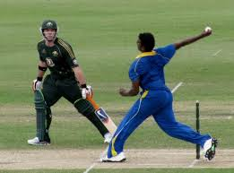
- What does it mean to stump the batsman?
Fielding positions:
- What is the main aim of the cover?
- What is the job of the wicketkeeper?
- Where is the mid-wicket positioned?
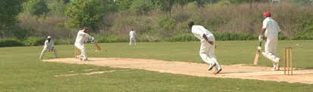
- What is the job of a mid-off? Who typically plays this position and why?
Field Characteristics:
- What is the bowling crease?
- What are the two concentric circles around the pitch called?
- Where does the non-striker batsman stand before the bowl?
- How far is it, in yards, from one wicket to the other?

